BANK
Objective
All the banks operating in India are controlled by RBI. (e.g. minimum interest rate, minimum balance allowed, maximum withdrawal limit etc) which all banks must follow. For example, suppose RBI has set minimum interest rate applicable to a saving bank account to be 4% annually. however, banks are free to use 4% interest rate or to set any rates above it. Write a JAVA program to implement bank functionality in the above scenario and demonstrate the dynamic polymorphism concept. Note: Create few classes namely Customer, Account, RBI (Base Class) and few derived classes (SBI, ICICI, PNB etc). Assume and implement required member variables and functions in each class. Testcase1: Enter the Bank name to find the rate of Interest : RBI RBI rate of interest is : 4% Testcase2: Enter the Bank name to find the rate of Interest : SBI RBI rate of interest is : 7%
Algorithm
• Start
• Import the Scanner class and create a Scanner object to accept input from the user.
• Display a message asking the user to enter the bank name: RBI, SBI, ICICI, or PNB.
• Read the bank name and convert it to uppercase.
• Declare a reference variable of type RBI:
RBI bankReference;
• Use a switch statement to create the appropriate bank object:
- If bank is SBI, create new SBI().
- If bank is ICICI, create new ICICI().
- If bank is PNB, create new PNB().
- If bank is RBI or any other value, create new RBI().
• Call getInterestRate() using the bankReference.
• The appropriate overridden method is executed at runtime:
- RBI → 4.0%
- SBI → 7.0%
- ICICI → 6.0%
- PNB → 5.5%
• Display the selected bank's rate of interest.
• Close the Scanner object.
• Stop.
Code
package record;
import java.util.Scanner;
class RBI {
public double getInterestRate() {
return 4.0;
}
}
class SBI extends RBI {
@Override
public double getInterestRate() {
return 7.0;
}
}
class ICICI extends RBI {
@Override
public double getInterestRate() {
return 6.0;
}
}
class PNB extends RBI {
@Override
public double getInterestRate() {
return 5.5;
}
}
class Customer {
private String name;
private int customerId;
public Customer(String name, int customerId) {
this.name = name;
this.customerId = customerId;
}
public String getName() {
return name;
}
}
class Account1 {
private String accountNumber;
private double balance;
private RBI bank;
private Customer customer;
public Account1(String accountNumber, double balance, RBI bank, Customer customer) {
this.accountNumber = accountNumber;
this.balance = balance;
this.bank = bank;
this.customer = customer;
}
public void displayAccountDetails() {
System.out.println("Customer Name: " + customer.getName());
System.out.println("Account Number: " + accountNumber);
System.out.println("Balance: ₹" + balance);
// Dynamic method dispatch at runtime
System.out.println("Rate of Interest: " + bank.getInterestRate() + "%");
}
}
public class Bank{
public static void main(String[] args) {
Scanner scanner = new Scanner(System.in);
System.out.print("Enter the Bank name to find the rate of Interest (RBI, SBI, ICICI, PNB): ");
String bankName = scanner.nextLine().trim().toUpperCase();
RBI bankReference;
switch (bankName) {
case "SBI":
bankReference = new SBI();
break;
case "ICICI":
bankReference = new ICICI();
break;
case "PNB":
bankReference = new PNB();
break;
case "RBI":
default:
bankReference = new RBI();
break;
}
System.out.println(bankName + " rate of interest is : " + (int)bankReference.getInterestRate() + "%");
scanner.close();
}
}

UML Diagram
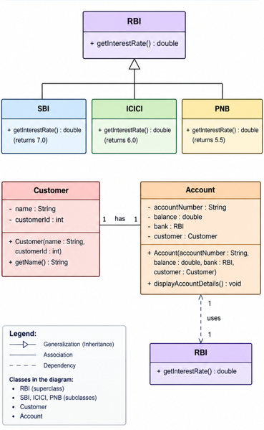
Output